1. 
2. In get(), remove(), we’re duplicating code.
3. So, let’s write a new method getEntry(int key)
4. 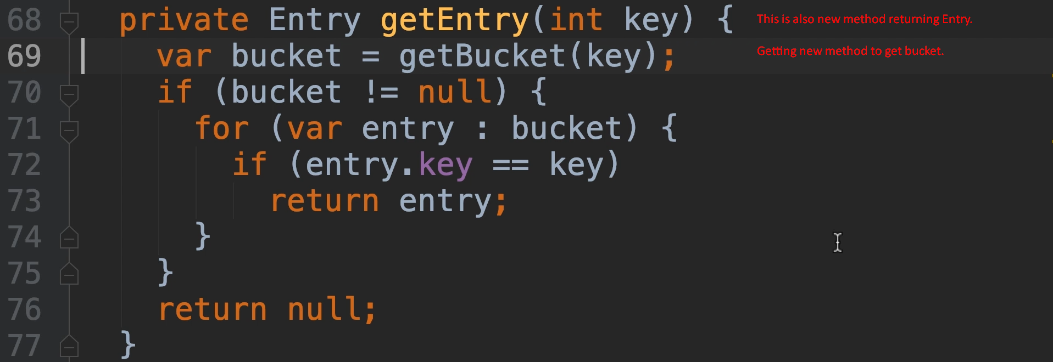
5. 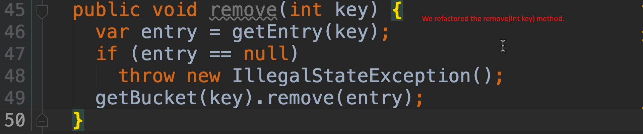
6. 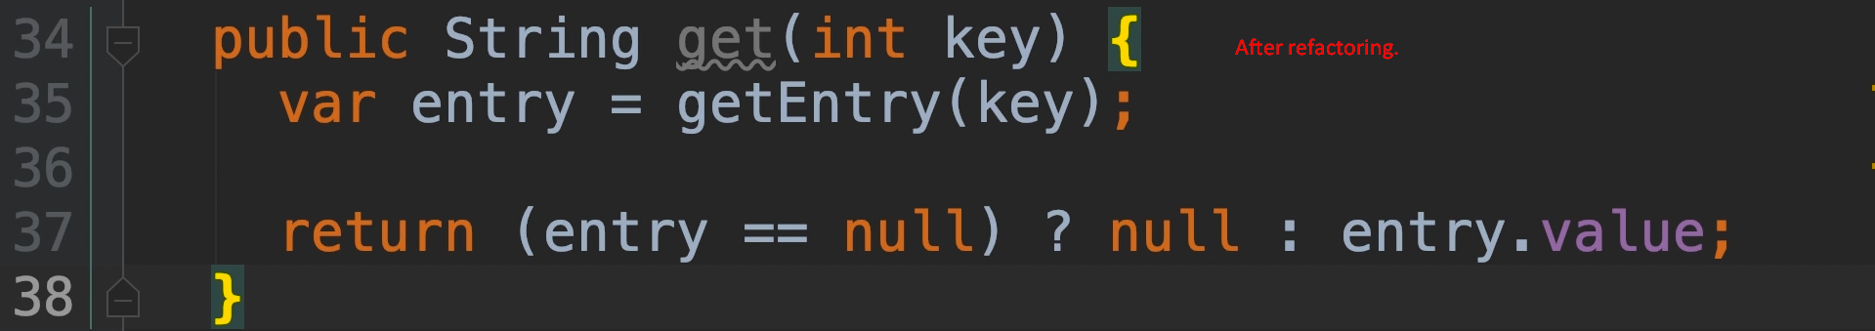
7. Command Query Separation Principle.
8. There were some more codes but I skipped.